MEET MRS. UNMACHT!
7th Grade Math

Hello! I am your child’s math teacher this year. I live in Sun Prairie with my husband and dog. I have 3 daughters who are off on their own now, as they are 25, 23 and 18 years old. Although I was born in Dubuque, Iowa, my family moved to Madison when I was entering high school—where I enjoyed playing volleyball, basketball and track. I went to UW-Madison for my undergraduate degree and UW-LaCrosse for my master’s degree. I have eight brothers and sisters including a twin sister.

Like last year we will be using the i-Ready math diagnostic at the beginning, middle, and end of this school year. The beginning of year diagnostic usually takes students about 3 math periods to complete. In class we’ll discuss the importance of trying your best because students will be given lessons and assignments based on their diagnostic results; we’ll also explain that students don’t need to stress about the diagnostic, that they just need to show what they know, as it gives us detailed information about where each student is in math and what they have and have not learned. Please encourage your child to get some rest this week, and bring a charged Chromebook, water bottle and ear buds to math class.

You can find our course syllabus here. I will be posting assignments in google classroom, and grades will be updated regularly in Infinite Campus. Click here to find the weekly homework planner, which lists the math assignments; it is also in our math google classroom for students to see. Feel free to visit our classroom website at www.unmacht.weebly.com where you can find more information about this class, fun math games, and more. I look forward to a terrific year, and a great deal of learning, hard work and fun! By working together, we will make great things happen.

If you ever have any questions or concerns, please let me know right away. I am dedicated to making this an awesome year of math. You may reach me by email at junmacht@madison.k12.wi.us. Thanks a 10⁶!

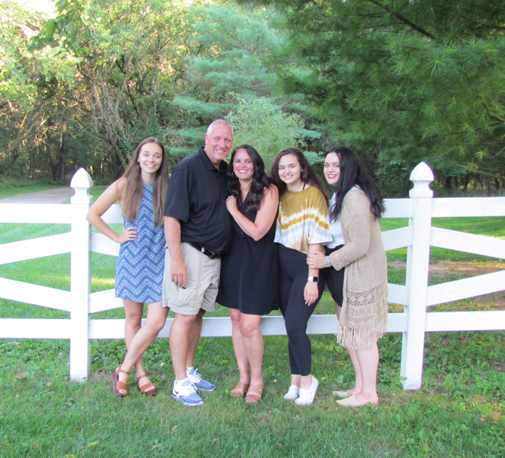

Mrs. Unmacht’s Favorite Things
-Spending time with my family and friends--
especially my husband and three daughters
-Teaching math and helping my students
-Camping
-Kayaking
-Hiking and being outdoors
-Baking and cake decorating
-Relay for Life; I’m a 16 year cancer survivor
-Playing basketball and volleyball
-Going to Badger football and basketball games

